Multi-Party Multi-Period Supply Chain Coordination

Thin-Yin Leong^{α} and Michelle LF Cheong^{β}

^{α} Practice Associate Professor, tyleong@smu.edu.sg

^{β} Practice Assistant Professor, michcheong@smu.edu.sg

School of Information Systems, Singapore Management University

80 Stamford Road, Singapore 178902.

We use the following test settings for all three examples:
- Demand for product R_{jt} is randomly generated based on a Normal distribution N~(100, 25).
- Bill of material, g_{jk} = 1 $∀ j,k$.
- Parts holding cost h_{jk} = $1 per part per day $∀ j,k$.
- Dedicated single source
  - a_{jks} = 1 for s = k, $∀ j,$and for k ≤ 4 in Example A.
  - a_{jks} = 1 for s = k, $∀ j,$and for k ≤ 8 in Example B.
  - a_{jks} = 1 for s = k, $∀ j,$and for k ≤ 12 in Example C.
  - That is, supplier 1 can only produce part 1, supplier 2 can only produce part 2, and so on. This represents the situation where there is a dedicated single source for each part and each part costs $10 (C_{jks} = $10).
- Flexible source
  - a_{jks} = 1 for $∀ j$ and for k = 5 in Example A
  - a_{jks} = 1 for $∀ j$ and for k = 9 in Example B
  - a_{jks} = 1 for $∀ j$ and for k = 13 in Example C
  - That is, the last supplier is able to product all the parts. Being a flexible source, the cost of each part will be higher, and we set a 50% price premium of $15 per part (Cjks = $15).
- a_{jks} = 0 otherwise
- Lower inventory limit = 25 $∀ j,k,$and t ≤ 5, = 50 $∀ j,k,$and t = 6. The at the last period of the time horizon is set at a higher value to take care of sudden surge in demand beyond the time horizon.

- Upper inventory limit = 75 $∀ j,k$.
- Minimum order quantity = 0 $∀ j,k,s,t$.
- Maximum order quantity = 100 $∀ j,k,s,t$and a_{jks} = 1, 0 otherwise.
- Relative difference tolerance $ε$ = 0.5%.

As the number of products, parts and suppliers increase from Example A to C, the following are set differently:
- Suppliers’ capacities for producing the parts have to be increased accordingly.
- Example A:
  - $\overset{{\hat{}}_{\text{kst}}}{O}$ = 300 for s = k, $∀ t$.
  - $\overset{{\hat{}}_{\text{kst}}}{O}$ = 500 for s = 5,$∀ t$ .
  - $\overset{{\hat{}}_{\text{kst}}}{O}$ = 0 otherwise.
- Example B:
  - $\overset{{\hat{}}_{\text{kst}}}{O}$ = 700 for s = k, $∀ t$ .
  - $\overset{{\hat{}}_{\text{kst}}}{O}$ = 1100 for s = 9,$∀ t$ .
  - $\overset{{\hat{}}_{\text{kst}}}{O}$ = 0 otherwise.
- Example C:
  - $\overset{{\hat{}}_{\text{kst}}}{O}$ = 1100 for s = k, $∀ t$ .
  - $\overset{{\hat{}}_{\text{kst}}}{O}$ = 1700 for s = 13,$∀ t$ .
  - $\overset{{\hat{}}_{\text{kst}}}{O}$ = 0 otherwise.

Example A-1: Asynchronous Bidding, Method 1.
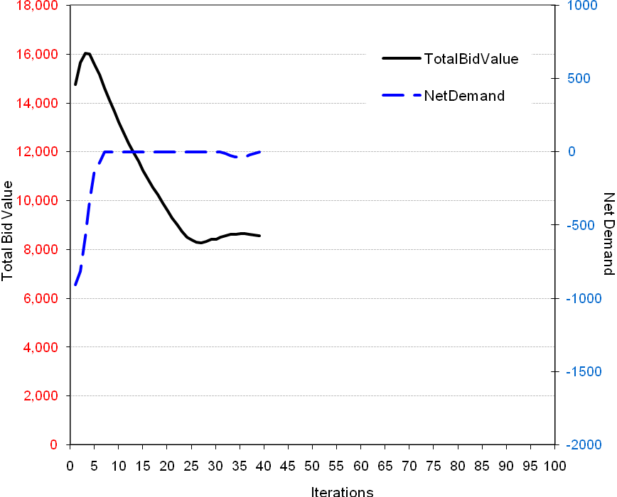
Example A-2: Asynchronous Bidding, Method 2.
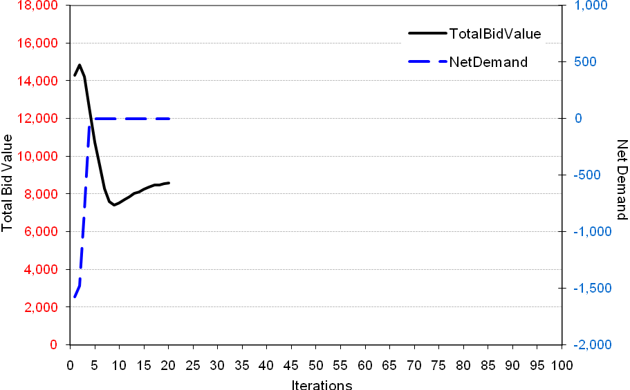
Example A-3: Asynchronous Bidding, Method 3
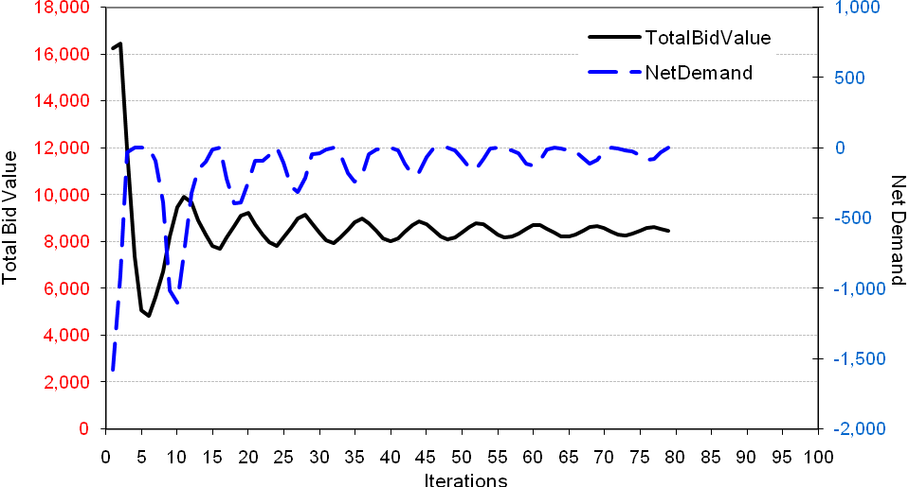
Example A-4: Synchronous Bidding, Method 1.
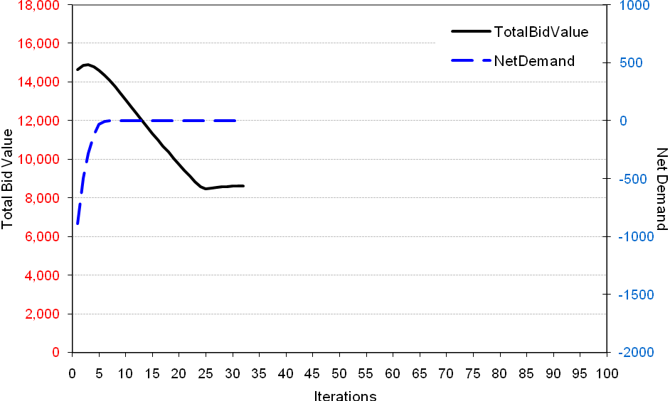
Example A-5: Synchronous Bidding, Method 2.
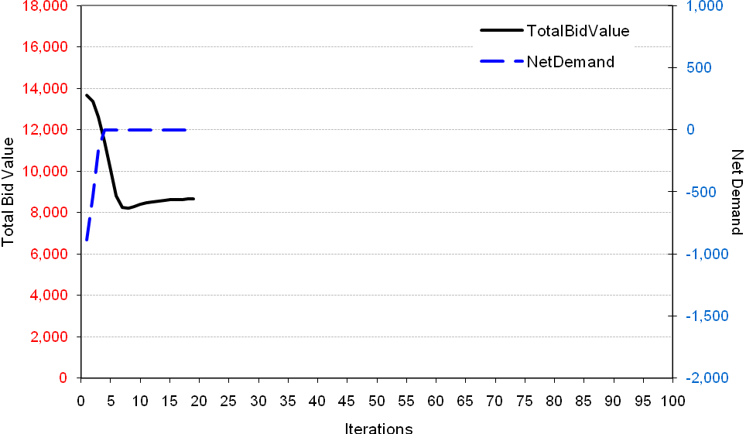
Example A-6: Synchronous Bidding, Method 3.
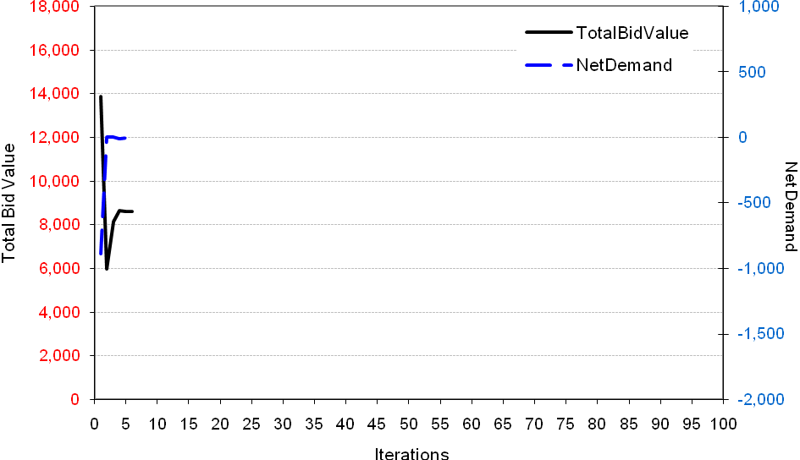
Example B-1: Asynchronous Bidding, Method 1.
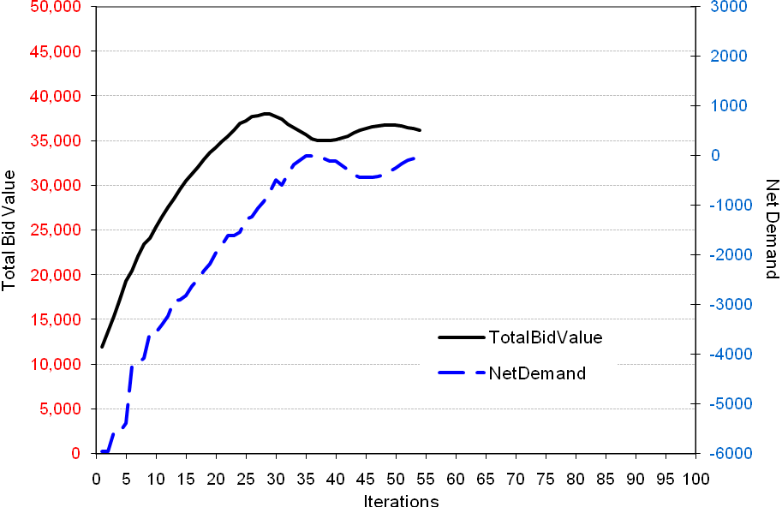
Example B-2: Asynchronous Bidding, Method 2.
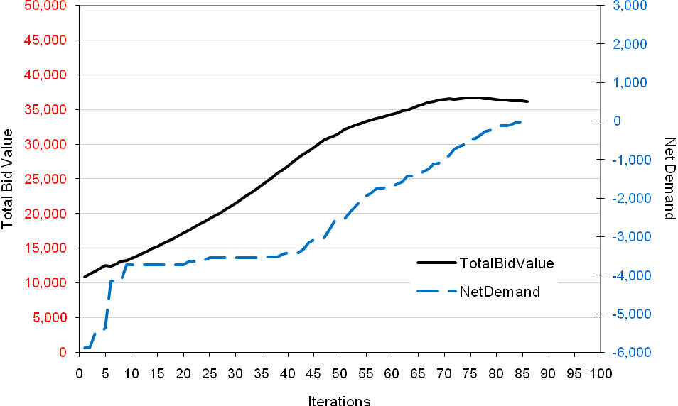
Example B-3: Asynchronous Bidding, Method 3.
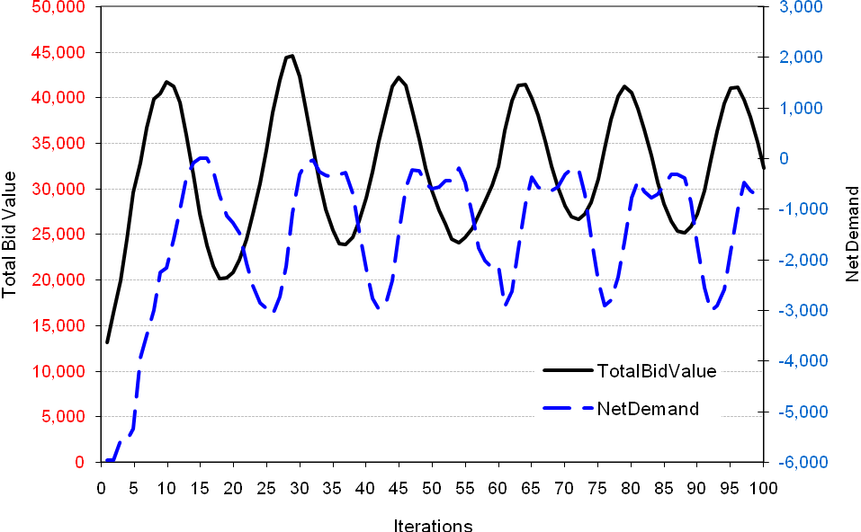
Example B-4: Synchronous Bidding, Method 1.
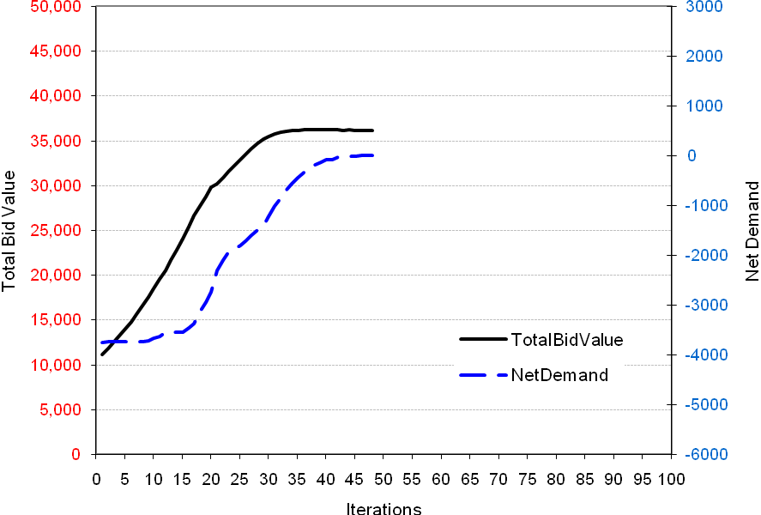
Example B-5: Synchronous Bidding, Method 2.
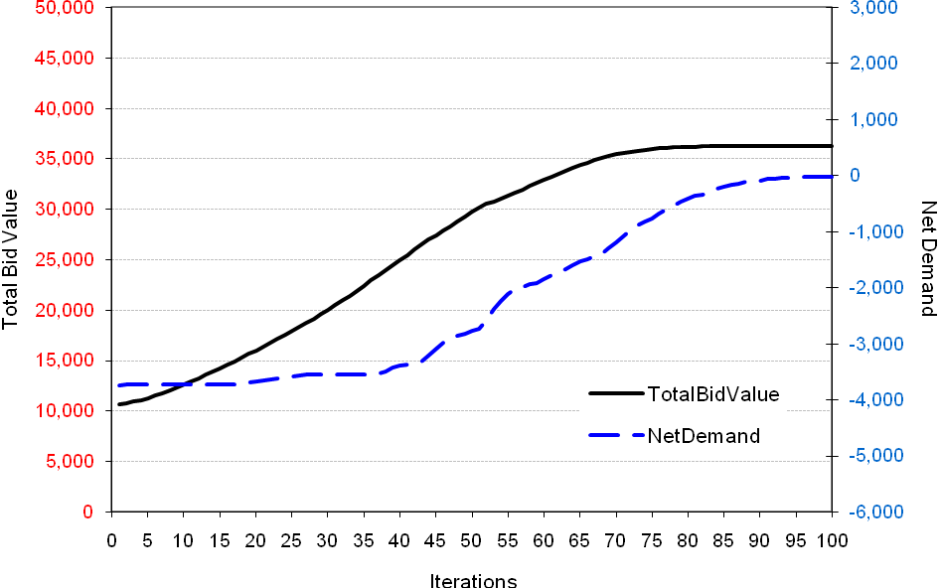
Example B-6: Synchronous Bidding, Method 3.
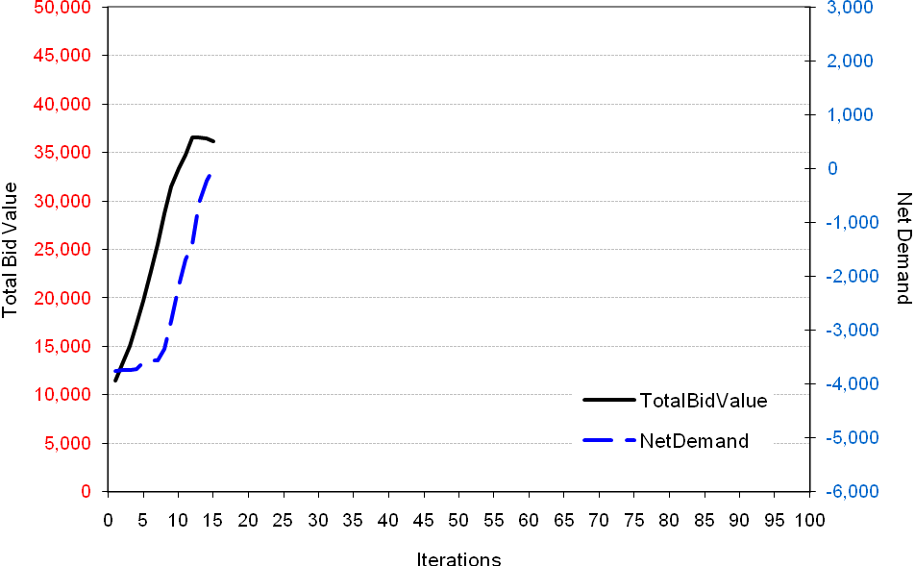
Example C-1: Asynchronous Bidding, Method 1.
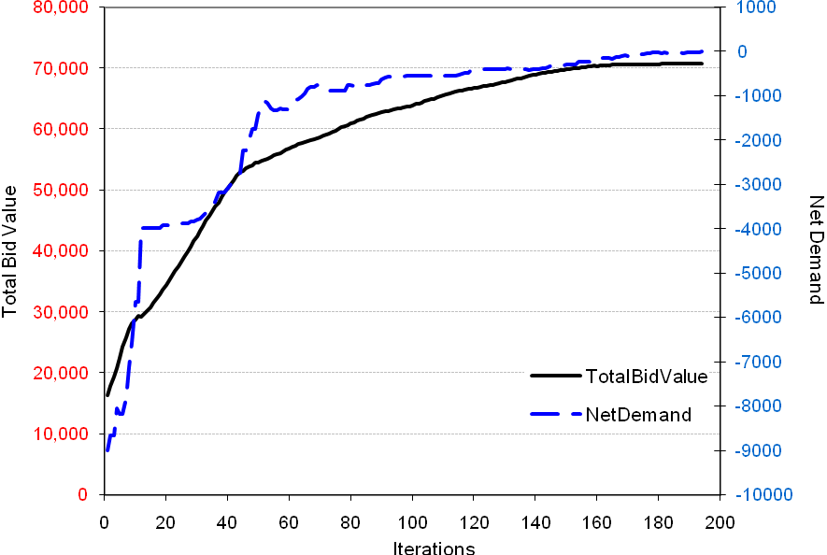
Example C-2: Asynchronous Bidding, Method 2.
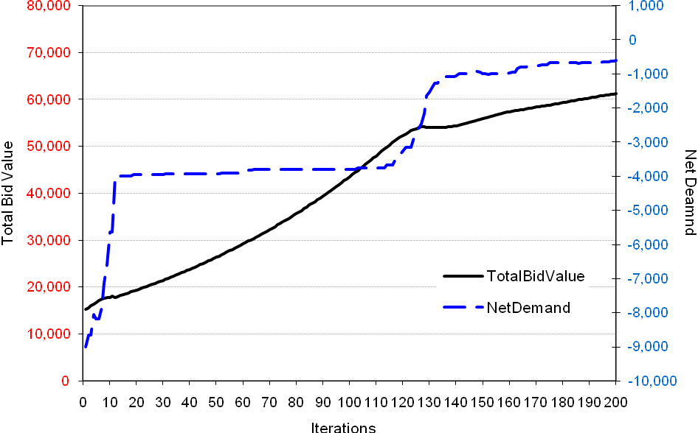
Example C-3: Asynchronous Bidding, Method 3.
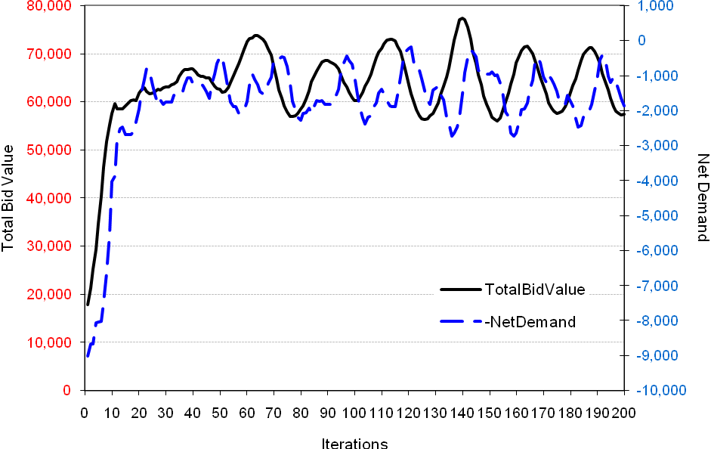
Example C-4: Synchronous Bidding, Method 1.
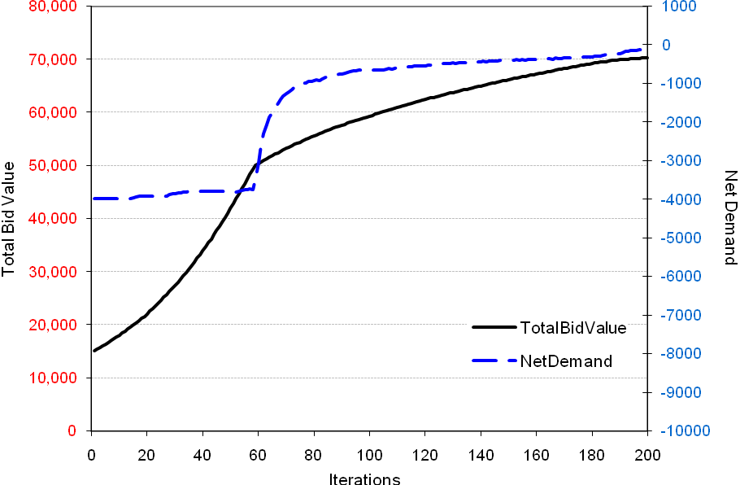
Example C-5: Synchronous Bidding, Method 2.
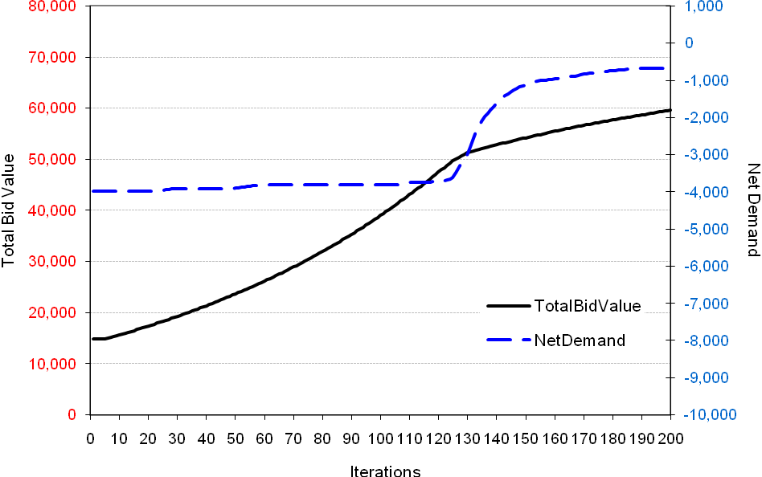
Example C-6: Synchronous Bidding, Method 3.
